**Lifecycle Exercise**

Question : **Create a cart application having a form component to add new items in cart, a itemlist component to display added items and CartTotal to show total amount.**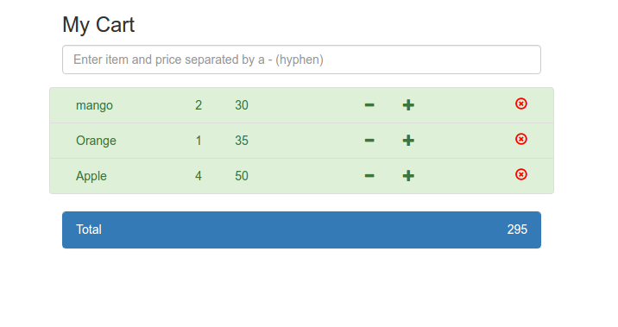

Solution : please find react3rd.zip

P.S: textbox has onBlur event instead of onChange , because i wanted it to store data when input is complete instead of letting it save each alphabet in states.

After input is complete, just press tab button or click anywhere on screen to store data, as the event fires when the textbox loses focus.